OK....I’ve signed up for a class in OVS! Now what?!?!
Sign in to your OVS/FLVS account and select the class you want to go into from the dashboard:
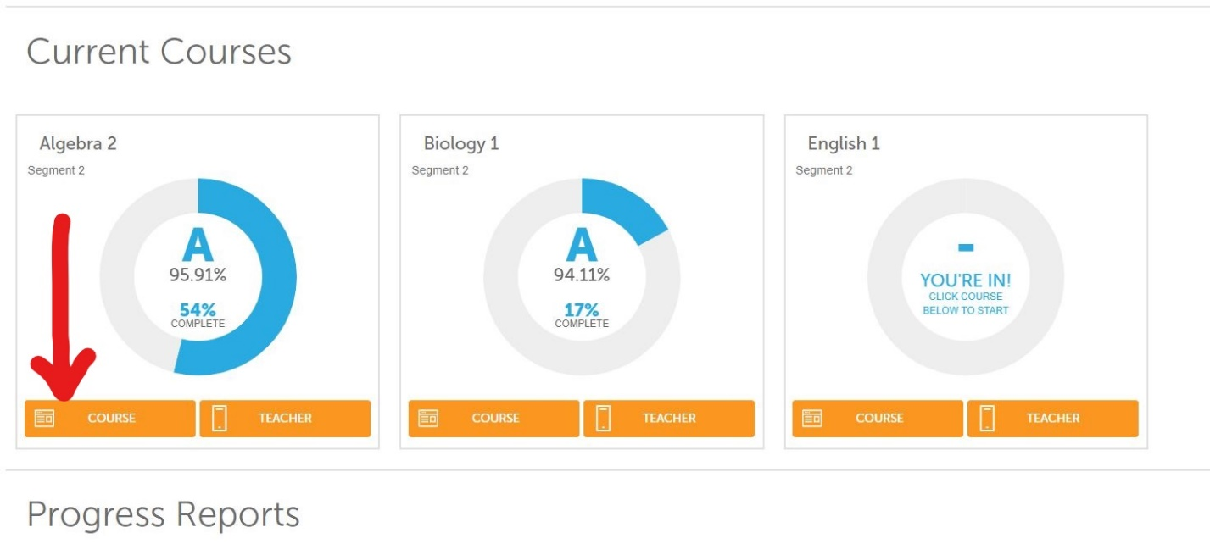Click on the “Course” button to go into that class:
On your teachers page you will see a “How to Complete a Welcome Call” or “Welcome New Students” link to click. Depending on the teacher, this may look different or be in a different location, however all teachers will have a process indicated for completing the “Welcome Call”. Click the link and review all the information that your teacher is providing on how to proceed through the course.
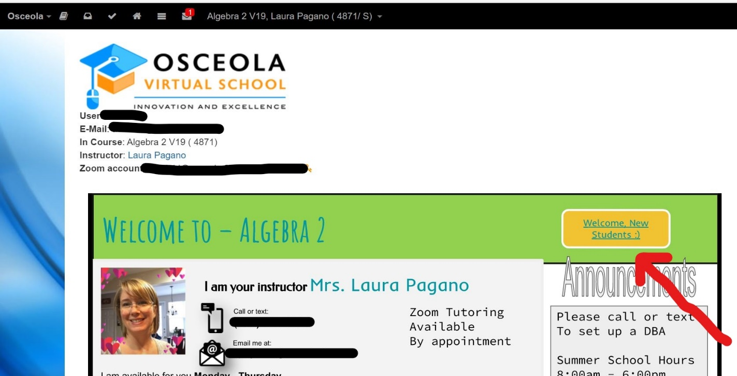

If you click on the 3 three lines (hamburger) at the top of the screen, you will find many of the resources you need to navigate the course (red arrow):
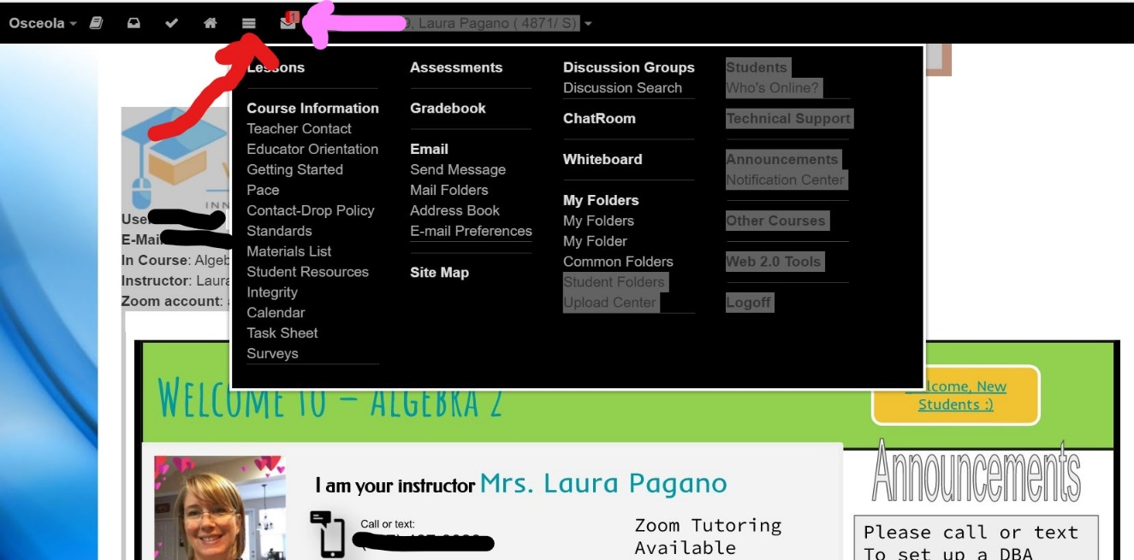
You will also see other helpful icons, including your email link (pink arrow) at the top of the screen. To access your assignments, click the “Assignments” tab at the top of the page (red arrow):
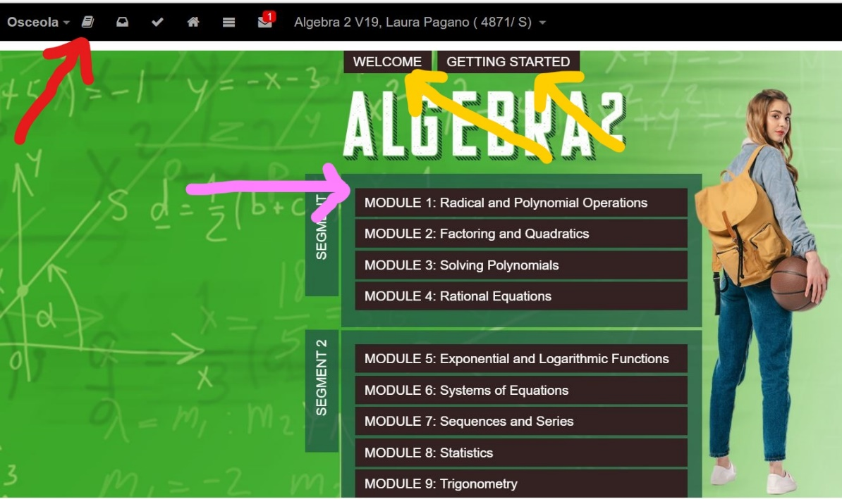
And then click on your first assignment to get started (pink arrow). Please make sure you complete all assignments in order!
Please note that there is also a “Getting Started” and a “Welcome” tab at the top of this page to give you additional information (yellow arrows).
There is also an “Educator Orientation” tab under the “hamburger” (three lines on the top menu), that provides you a tutorial on how to navigate this whole platform (red arrow).
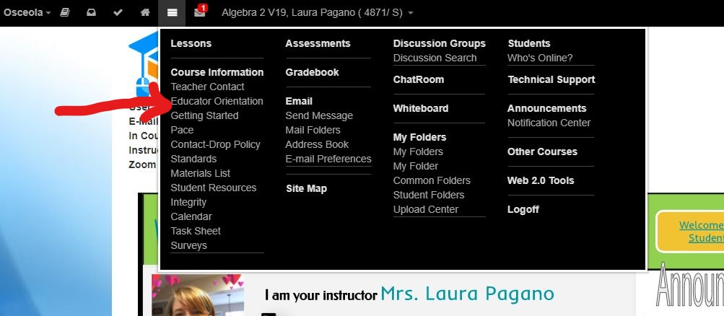
Many of your teachers will also add helpful links to their welcome screen like the “Help” button on this teacher page (red arrow) or the links for other practice websites/resources (pink arrows):
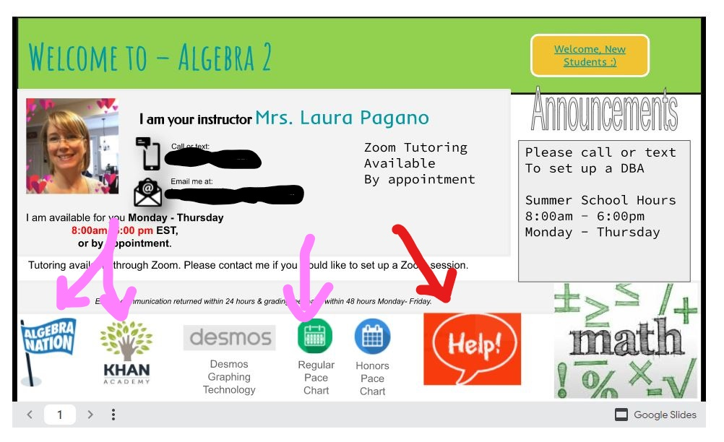
This should give you more than enough information to get you started. If you have additional questions please reach out to your teacher!
WELCOME TO THE OVS FAMILY!!!

